NETWORKING

Q. What is computor newtorking ?

ans : lot of computer connected to a newtork .

Q. What is internet ?

internet is collection of computer network .

==> Client-Server Artitect

Cilent- is basically a request we sent to server .

Server : Server connect with the data base fetch the information from database and sent to client as response .

* Protocol

protcol are set of rule set by internet sosiecty . eg : TCP ( transmission control protocol )

1. TCP (transmission control protocol ) : ensures the the we sent over the internet should to the reciver without be corrupted .

note: when use send data useing TCP data transfered in packet form the source and merge at the destination . so there is chage that the rordering of data or missing of data , merging of data is done by checksum.

1. checksum check the ordering of data and check wheter the data sent by the user is same as the data recived to the reciver.
2. Timer :timer tell use about whter the data has been recived by the reciver or not . when we sent data then timer started and when the data recived timer stops , it data did’n recived the timer get expired .

featues fo tcp:

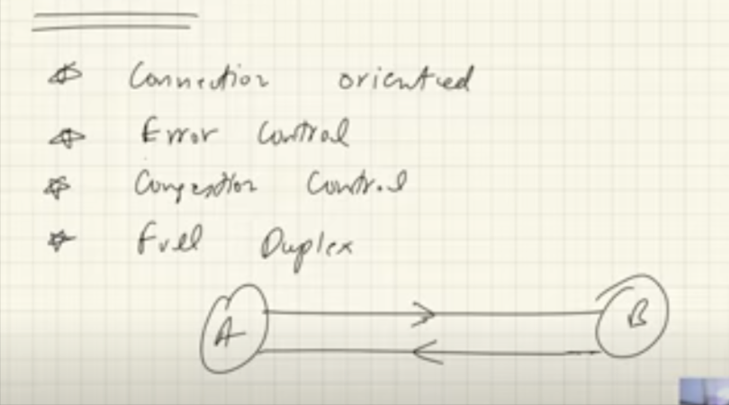

1. UDP (user dataGram protocol ) : if we do not care of 100% data should reached the reciver then we use UDP . eg : vido confrencing.

note:UDP IS connection less protocol

Note: UDP IS lot FASTER THAN TCP that’s why we use UDP .

features of UDP :

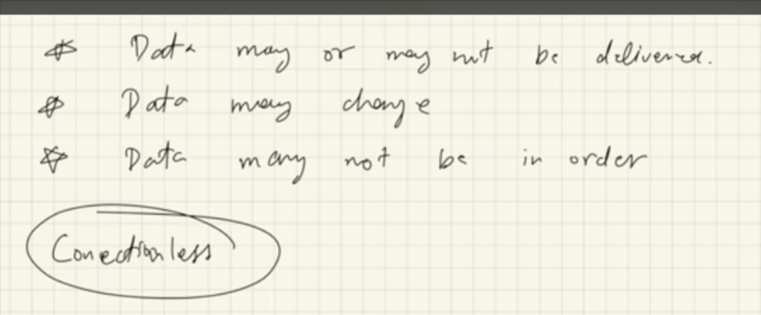

1. HTTP : (hyper text transfer protocol ) : it is used by world wide web (www) basically it defines the formate of the data that being transferd between cilent and server
2. IP : (internet protocol ) : read below

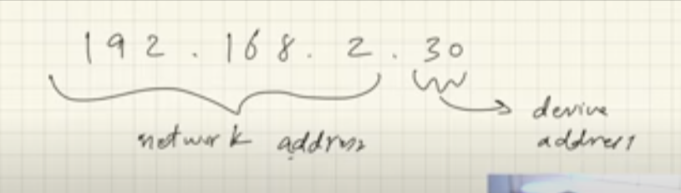

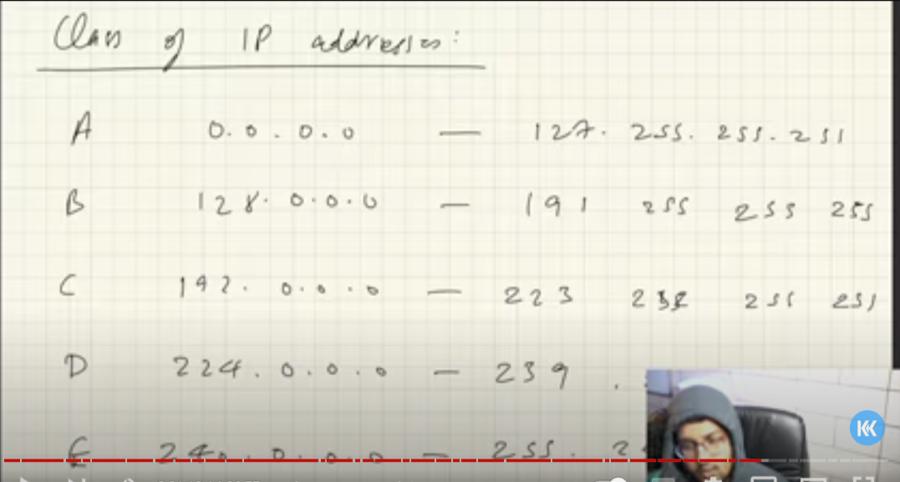

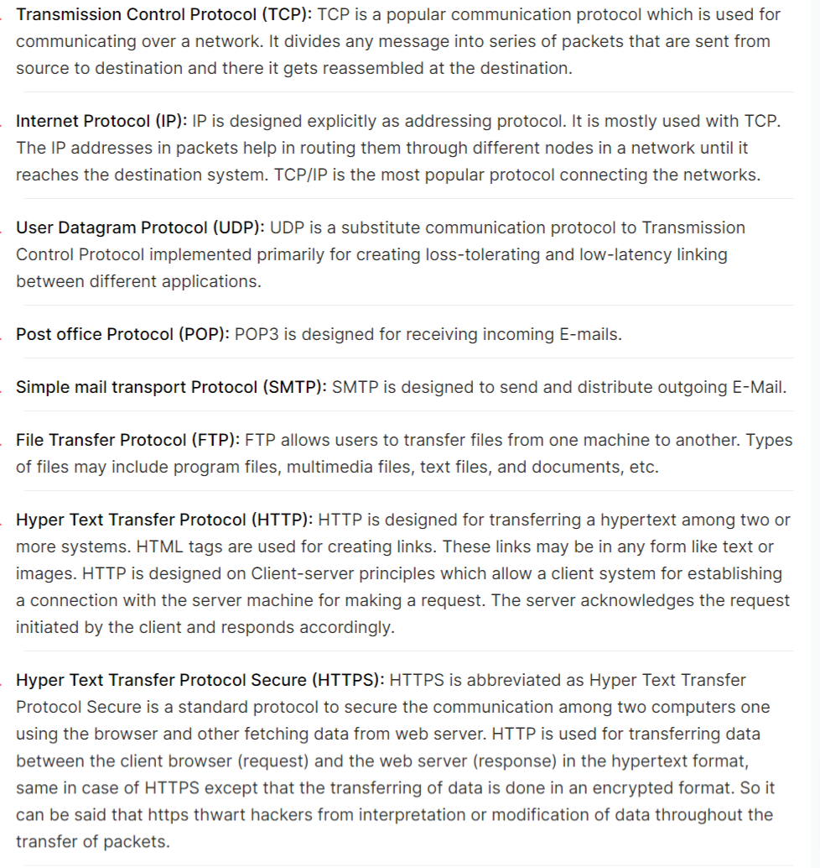

* LAN , MAN ,WAN

LAN : (local area network ) : it is used for short range networking . eg . ethernet ,wifi

MAN: metropolition area network :across city

WAN :wide area network eg : optical cable fibers

what is modam ?

modam is used to convert digital signal into analog signal and vice versa

what is Router ?

Router is device used to route the data packet based on their IP address .

ISP : Internet Service provider

TOPOLOGIES : Topology defines the structure of the network how all the components are interconnected to each other

1. BUS : in bus toplogy component are connected through single cable .

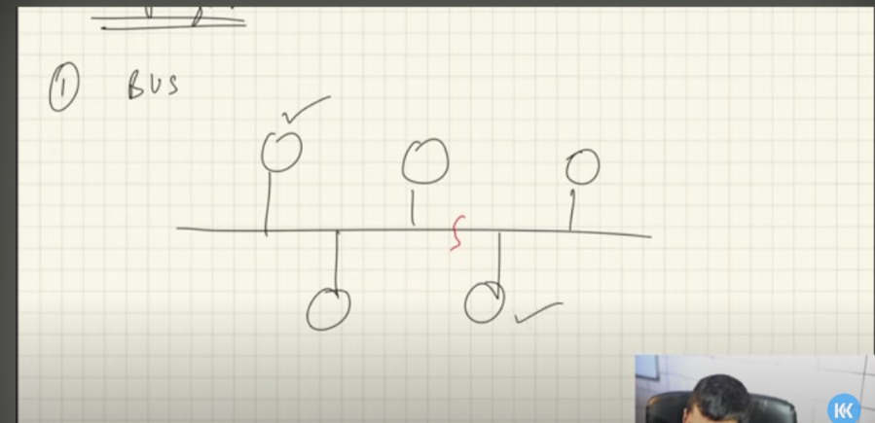

limitation of bus toplogy : if cable breaks the computer loss newtork .

ii ) RING : in ring toplogy computer are connected in a ring . each computer is connected to each other.

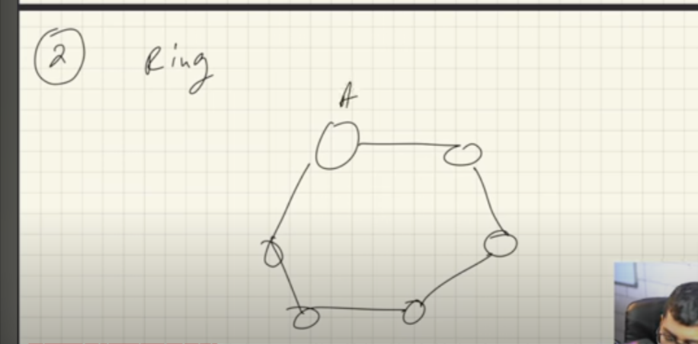

limitation of Ring toplogy :

1. if ring breaks the computer loss network .
2. if we want to send data form one computer to another computer since in ring each computer connected each other , so we need to make unneccsary calls .
3. STAR Toplogy : in start toplogy one controlling device connected to diffrent computer .

if i want to send data from one computer to another computer then it has to be passed through connecting device .

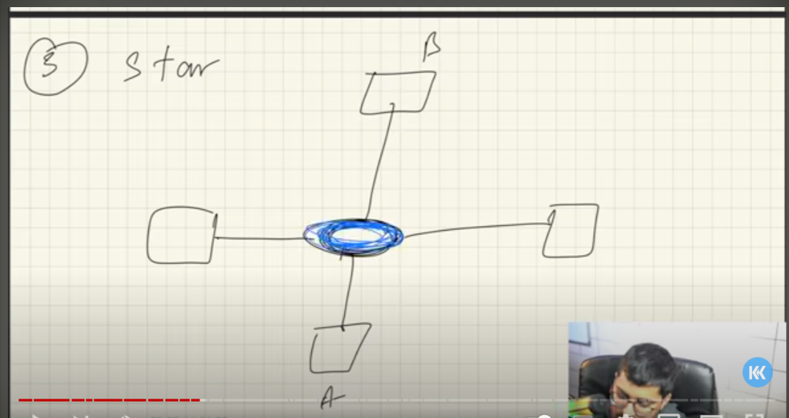

limitation : if central device fails the ntwork will be disconnected .

4) TREE Toplogy : it is combination of buss and star toplogy .

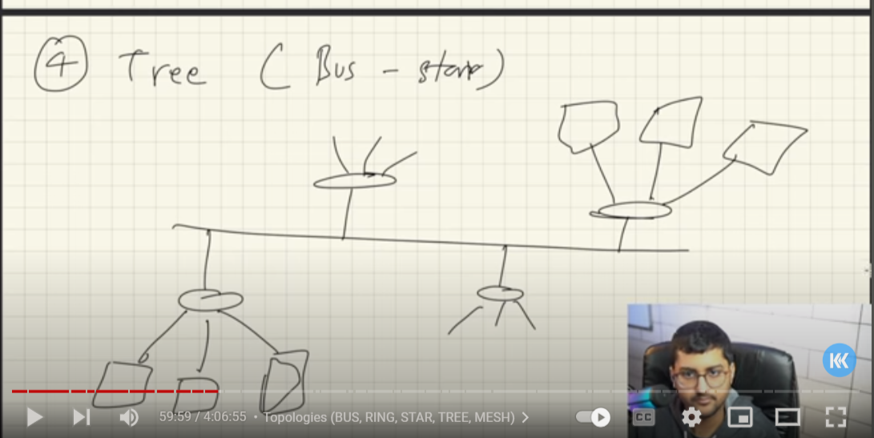

5)MESH Toplogy : in mesh toplogy every single computer is connected to other .

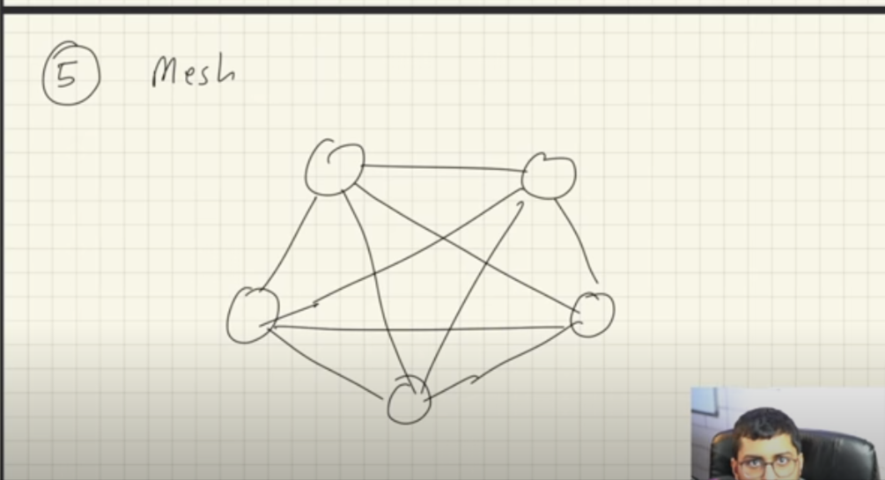

limitation :

1. it is expensive because it require more cable.
2. it i want to connect one more computer the i have to make connection with the remaning other.

* STRUCTURE OF NETWORK

OSI Model : open system interconnection model

it is standard way about how computer are interconnected to each other about how sever commnicated .

Layes of OSI model :

i) application layer : it is user space where user send request. we sent requst from applicaton layer to presentation layer .

protocol used are : HTTP ,HTTPS ,FTS,SMTP

ii) Presentation layer : presentation layer get the request form the application layer and converted them into a binary form.

iii)sesion layer : sesion layer get the data from the presentation layer it helps it setting the connection and terminate the existing connection and it autheticate the data .

iv)transport layer : it get the data from the sesion layer convert the data into small data unit called segment , every segment contains the source and destionation port no and sequence because all the data can not be transfered as whole it transfered into chucks .

transport layer transport the data from network to application

transport layer protocol protocal : TCP , UDP

v)network layer : router is present here . the function of network layer is logical addressing . It assign the sender and reciver ip address to every segment and forms IP Packet and it also perfom routing to diffent node in network so the packet reach to its desitination.

Network level protocol : IP

network layer transport the data from one computer to other computer

vi)Data link layer : it do physical addressing of packect we recive from the network layer . it assign mac address to packet to farme called data link.

mac address : is 12 digit alpha numeric no computer netwok interface .

vii)physical layer : it get the data from the data link layer and convert them into bits tranport the data to hardware like cable

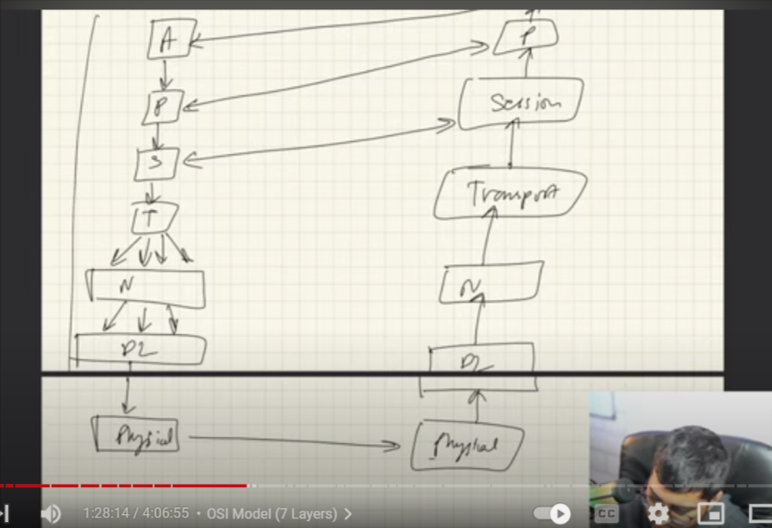

TCP/IP Modal :

it is similar to OSI modal but in TCP/IP modal have 5 layer .

i)application layer

ii)transport layer

iii)network layer

iv)data link layer

v)physical layer

1.Application layer deep :

i) user space where user intract with it

ii) present in user devieces

iii)ping time : eg : ping google.com

note :we have two artictecture

1. client-server artic
2. p2p (pear-to-pear artitect ) (in p2p application running on various devices they are connected to each other there is no one dedicated server in it , every computer can act as server and client )

networking devices :

i)modam

ii)routers

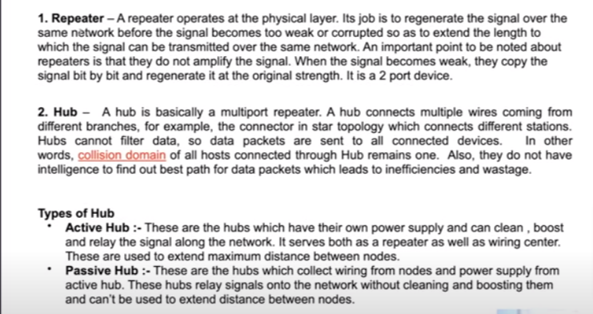

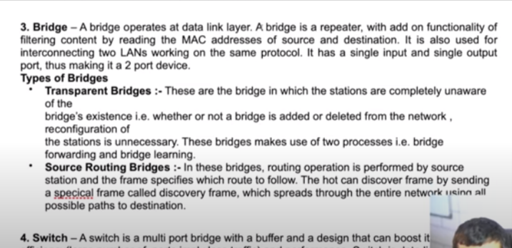

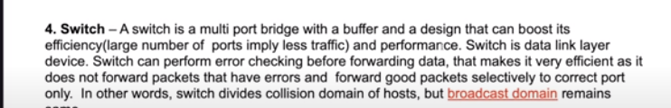

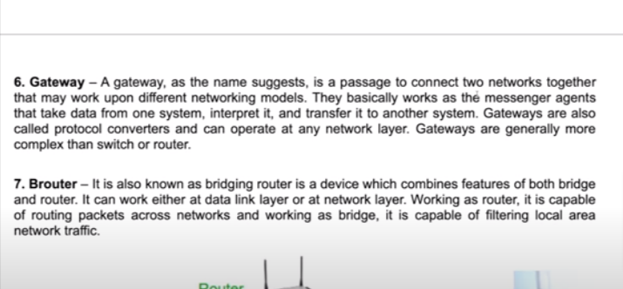

socket : it is interface between process and internet . client-server kind of thing.

diffrence between ip adress and port :

ip adress : ip adress tell which device we are working with

port: tell which application we are working with eg : http :80 mongodb:27017 mysql port : 3306

HTTP : http uses TCP insed it

1. Http is stateless protocol (means server will not going to store any information of client means client keep on requesting again and agin it will not going to sotre any infromation it create a cookies on user local sotrage inform of string )

METHOD :

1. post
2. get
3. put
4. delete

status code :

1XX:informational code

2XX : sucess code

3XX: redirecting code

4XX:client error code

5XX: internal server error code

DNS : (Domain Name System)

when we type google.com the http take that request and convert that domain name into IP adress then connect to the server of google.com

i) we have domain we have subdomain (email.goole.com where email is subdomain and google is second lever domain and .com is top lever domain )

Q. what will happen when we type google.com

step 1: http get this request and first it search in own computer local chache beacuse when we visit any website for the first time it store the ip adress of that web site locallay .

step 2 : it it did’nt find on local server dns server(ISP internet service provider)

step 3 : then it search in root server

step 4 : it it serach in top domain server and get the ip adress

step 5 :after getting ip adress it redirct to use on google.com

Transport layer protocol :in detail

i)application layer send lot of raw data TCP divide , transport layer get the data and divide the data into the segement and add headder , checksum ,timer

ii)it also get the data from the network and transfer to the application

iii) app assign the segement with the source and destination PORT .

CONGESTION CONTROL :

- Takes care of two things

i) when does not arrive

ii) maintaining the order of the segement

3-way handshake

- suppose i want to estiblish connection with my friend computer . i send request to my friend network , my friend responded with he want also want to estiblish connection with me , and my network respond and connection estiblish .

